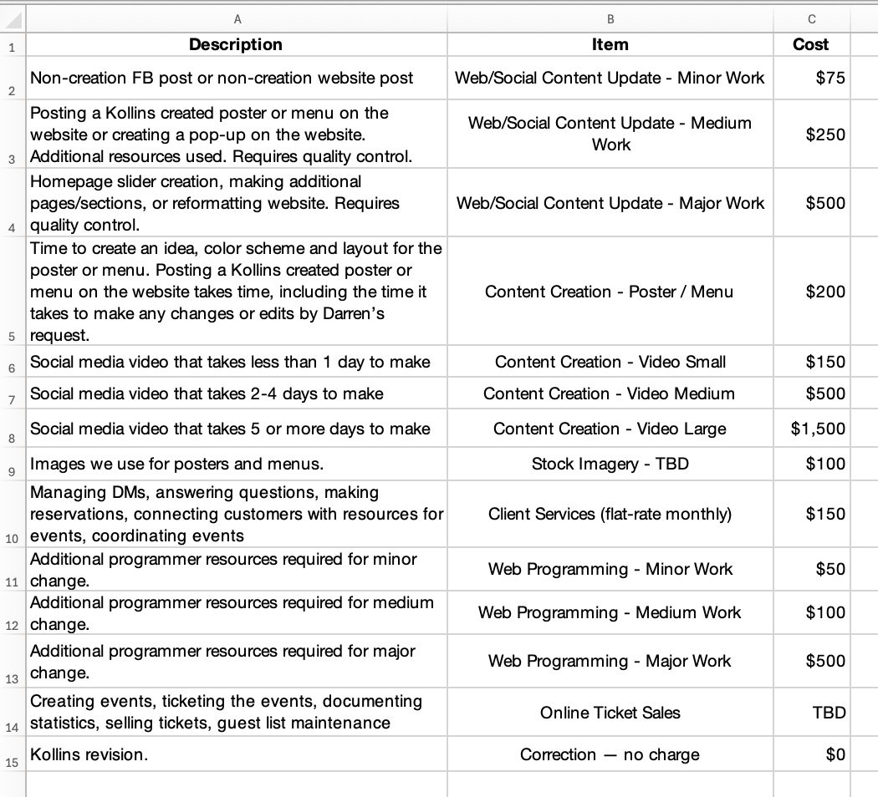

What You Missed Video
- Content creation - Video Large ($1500)
- Website update - Major ($500)

Valentines Day
- Website update - Minor ($75)

Superbowl Menu
- Content creation - Menu ($200)
- Website update - Minor ($75)

Full Moon
- Website update - Minor ($75)

St Patrick’s Day
- Content creation - Menu ($200)
- Website update - Medium ($250)

Foxy’s Madness
- Website update - Minor ($75)

Family Fun Day
- Website update - Minor ($75)

Past Events page
- Website update - Major ($500)
- Web programming - Medium ($100)

